

Project Scope Management

PJM 6005

Assignment 1

Title: Business Requirements & Stakeholder Assessment

Rahu Iyer

Professor Name: Ann-Marie Dunphy

**CONTENTS:**

Overview (Manufacturing Case Study)

1. Background
2. Scope
   1. Boundaries
   2. Assumptions
3. Success Criteria
4. Benefit Triggers/Value
5. Flexibility Matrix
6. Requirements Definition
   1. Functional Requirements
   2. Non-Functional Requirements
      1. Performance Requirements
      2. Reliability Requirements
      3. Reusability Requirements
   3. Requirement Dependencies
7. Stakeholder Register Assessment

Appendices

**Overview:**

The client is a billion-dollar manufacturer and marketer of beauty, personal care, and household products around the globe. The organization desires to expand its global appeal soon and therefore is in search of a new manufacturing facility which has 475,000-square-foot area with state-of-the-art technology fully functional within a year (Case study, n.d.).

**1. Background**

The cosmetic giant has decided to undertake another manufacturing facility to keep up with increasing customer demands and maintain competitiveness at the same time. The search for location of the facility was conducted in 28 states of the United States (Case study, n.d.). They modified their search to have a large facility with advanced technology to ensure that their products are of optimum quality.

**2. Scope Statement:**

Create an advanced manufacturing facility having 475,000 sq. ft. area, producing good quality cosmetic products with a budget of USD 60 million, under a year, to increase the profitability of the organization by meeting the customer’s rising demands.

**2.1 Assumptions:**

* All the project activities will be conducted sequentially with no gap between finish and start dates of dependent activities.
* The search for location of facility will take no longer than 18 days.
* The renovation of the facility will take no longer than 6 days.
* The demand for the product will be higher on completion of the project.
* There will be no delay between production readiness of the facility and its functioning.
* The payback period for the project is estimated to be 6 months.

**2.2 Boundaries:**

* Maintenance of the new manufacturing facility is not part of the existing project.
* PM Solution holds no accountability over the issues that may have arisen prior to the project undertaking.
* Marketing or advertisement of the cosmetic product is not included in the project scope.
* On completion, PM Solutions will have no control over the price of the final product. (The price of the product is manipulated by the organization’s sales department.)

**3. Success Criteria:**

* Gain significant market share, two months after the manufacturing facility is open and operational.
* Deliver affordable and good quality products.
* Payback period is less than 8 months.
* Develop a good reputation for the organization.
* Become the leader in the cosmetic industry globally.
* Set an example that can be used as a reference for manufacturing of new facilities worldwide.

Note: The payback period is estimated to be 6 months. But the success criteria has been defined as 8 months- an additional month, taking into account any uncertain factors/unforeseen event(s).

**4. Benefit Triggers:**

* Manufacturing facility is obtained at a reasonable price.
* The new manufacturing facility is large enough to meet customer demands.
* Location of the facility is suitable to reduce transportation cost.
* Error-associated cost and rework is minimum.
* Manufacturing facility is completed well-before time, without exceeding the budget.
* Output of production processes consists of very few defects.

**5. Flexibility Matrix**

|  |  |  |  |
| --- | --- | --- | --- |
| Flexibility | Low | Moderate | High |
| Scope |  | X |  |
| Budget | X |  |  |
| Schedule | X |  |  |

Table 5.1- Flexibility Matrix

Note: 1. State-of-the-art manufacturing facility is being established with the objective of serving more customers- a better quality product. Hence, flexibility is somewhat limited, applicable solely to the employment of certain production practices.

2. The estimated cost is approximately $ 54 million while the budget is $ 60 million with $6 million to spare, most of which is reserved for contingency plans. This leaves very limited flexibility for additional expenses.

3. Completing the colossal 475,000 sq. ft. facility within 1 year would require a lot of manpower co-ordination and accuracy. There is absolutely no room for error as an even the slightest mistake could potentially disrupt the timeline of other activities, delaying the over-ambitious project.

**6. Requirements Definition**

A new manufacturing facility would potentially align with the strategic goals of the organization, which is obtaining a wider global recognition and increase profitability by meeting the rising demands. All aspects of this highly complex, enterprise-level strategic initiative must be orchestrated as a coordinated effort to enhance the project’s success rate.

The requirements are further classified as:

* Functional Requirements
* Non-Functional Requirements

**6.1 Functional Requirements**

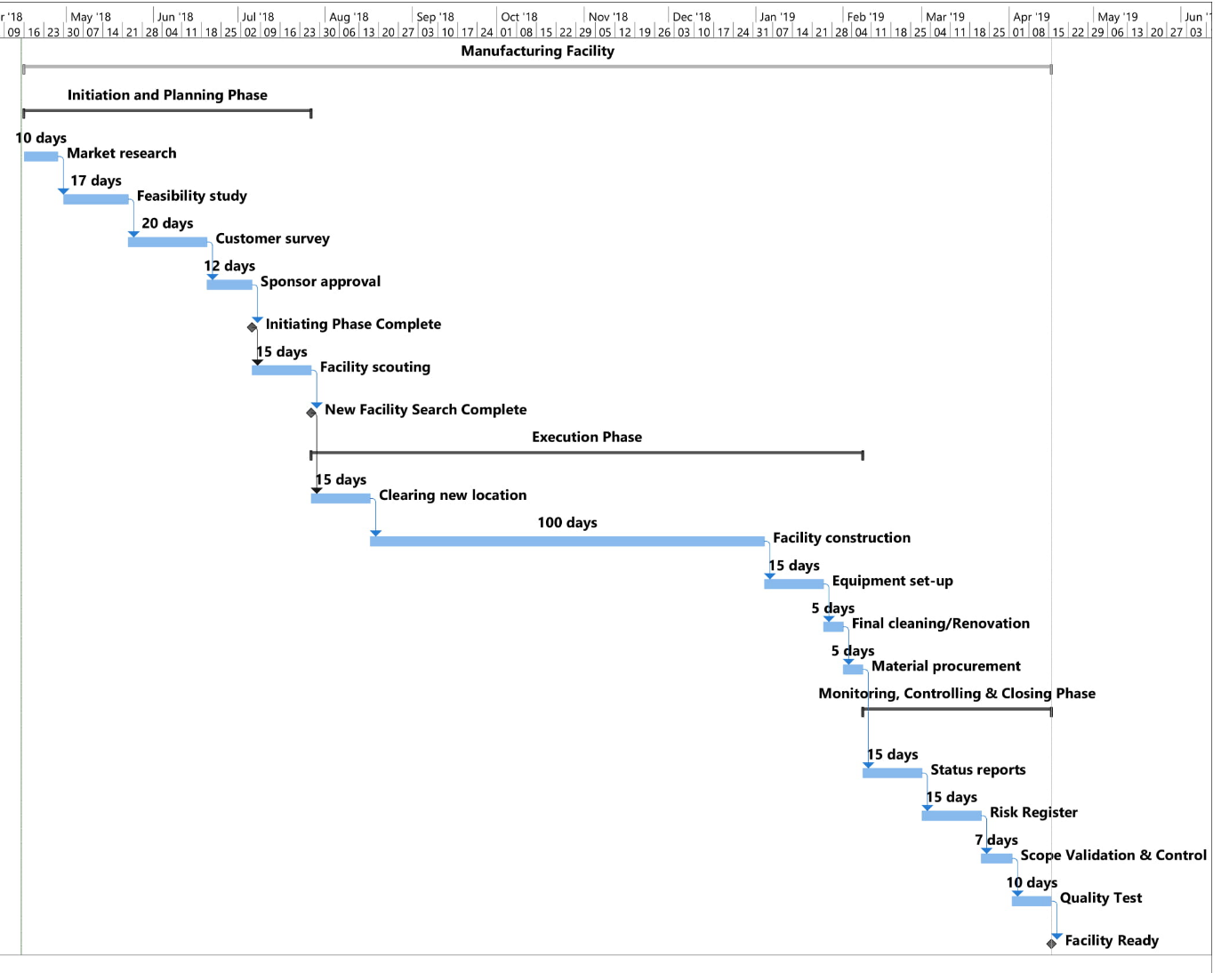Fig. 6.1- High Level Functional Decomposition

|  |  |  |  |  |
| --- | --- | --- | --- | --- |
| Requirement Code | Description | Priority | Performance Parameter | Issues |
| 001 | Facility search | Mandatory | Location | Financial |
| 002 | Market Research | Desirable | Statistics, Competitor analysis | Organization |
| 003 | Renovation | Optional | Cleanliness | Financial |
| 004 | Facility construction | Mandatory | Contactor’s workers | Design/Foundation. |

Table 6.1- Functional Requirements Description

**6.2 Non Functional Requirements**

**6.2.1 Performance**

|  |  |  |
| --- | --- | --- |
| Req. code | Factor | Limits |
| 015 | High Quality of products. | Increase in raw materials cost. |
| 017 | Rise in product sales. | Additional cost for advertisement |
| 018 | Reduction in defective products. | Implementation of better, advanced and costlier practices. |

Table 6.2.1- Performance Requirements

**6.2.2 Reliability**

|  |  |  |
| --- | --- | --- |
| Req. code | Factor | Limits |
| 030 | Long-term monetary benefits after establishment | Increase in rent as inflation increases |
| 032 | Close proximity to targeted customers | Concentration of demand in areas vary. |

Table 6.2.2- Reliability Requirements

**6.2.3 Reusability**

|  |  |  |
| --- | --- | --- |
| Req. code | Level | Strategy |
| 041 | Global | Integrate new manufacturing units into facility using a similar action plan. |
| 047 | Organizational | Standardize the utilization of lean manufacturing practices. |

Table 6.2.3- Reusability Requirements

**6.3 Requirement Dependencies**

Fig. 6.3- Requirement Dependencies

1. **Stakeholder Register Assessment**

|  |  |  |  |  |
| --- | --- | --- | --- | --- |
| Stakeholder’s Name | Position | Contact Information | Location | Role |
| Leonardo Bale | Sponsor | Email id (Preferred)-  [bale.leo@gmail.com](mailto:bale.leo@gmail.com)  Phone No.  +1-617-853-8954 | Boston, MA | 1. Approve/Disapprove the project  2. Revise the project  3. Provide the necessary monetary funds |
| Evan Matthews | Project Manager | Email id-(Preferred) [matthews.evan23@gmail.com](mailto:matthews.evan23@gmail.com)  Phone No.  +1-415-985-9899 | San Francisco, CA | 1. Develop an effective plan containing activities, milestones and deliverables.  2. Develop contingency plan for risks.  3. Assign human resources, budget and schedule for the activities. |
| PM Solutions | Program Manager | Email id-  [pmsolutions@gmail.com](mailto:pmsolutions@gmail.com)  Helpline No. (Preferred)  1800-256-8745 | San Francisco branch, CA | 1. Improve transparency between business units and senior leadership.  2. Monitoring and managing the schedule.  3. Assist with the translation of existing corporate policies to fit the new manufacturing culture. |
| Jack Alexander | Contractor | Email id- [alexander.jack@hotmail.com](mailto:alexander.jack@hotmail.com)  Phone No. (Preferred)  1-415-895-8752 | San Francisco, CA | 1. Hire labourers for working on-site.  2. Rent necessary equipment.  3. In-charge of the facility construction and maintenance. |
| Russel Gosling | Human Resource Manager | Email id-(Preferred) [gosling.russel@gmail.com](mailto:gosling.russel@gmail.com)  Phone No.  +1-415-853-9872 | San Francisco, CA | Hire employees to work in the new manufacturing facility production line. |
| Stephen Stark | Sales Department Manager | Email id-(Preferred)  [stark_stephen@gmail.com](mailto:stark_stephen@gmail.com)  Phone No.  +1-415-652-7854 | San Francisco, CA | 1. Conduct market survey.  2. Estimate demand of the product.  3. Develop strategies for advertisement of the advanced quality cosmetic-line products. |
| Clark Michael | Business Analyst | Email id-(Preferred)  [mike.clark@gmail.com](mailto:mike.clark@gmail.com)  Phone No.  +1-415-785-7423 | San Francisco, CA | 1. Build requirements (Dunphy, n.d.)  2. Engage key stakeholders to document aspects of project scope (Dunphy, n.d.). |
| Customers | End-users | Feedback/Comment on company’s website. | Worldwide | 1. Increase/decrease the demand of the product.  2. Purchase the product. |

Table 7.1- Stakeholder Register Assessment

**Appendices**

* List of figures:
* Fig. 6.1- High Level Functional Decomposition
* Fig. 6.3- Requirement Dependencies
* List of tables:
* Table 5.1- Flexibility Matrix
* Table 6.1- Functional Requirements Description
* Table 6.2.1- Performance Requirements
* Table 6.2.2- Reliability Requirements
* Table 6.2.3- Reusability Requirements
* Table 7.1- Stakeholder Register Assessment

**Reference:**

Dunphy, A. (n.d.). Week 3 Lecture_Scope. Retrieved April 28, 2018 from <https://northeastern.blackboard.com/bbcswebdav/pid-18059522-dt-content-rid-41268750_1/courses/PJM6005.80602.201835/Lecture_Week%203%20-%20Class%20presnetation.pdf>

Manufacturing Facility Case. (n.d.). Retrieved April 14, 2018 from <https://northeastern.blackboard.com/bbcswebdav/pid-18059498-dt-content-rid-40698676_1/courses/PJM6005.80602.201835/PJM6005.80602.201835_ImportedContent_20180403050026/Manu%20Facility_PMS.pdf>

Project Management Institute. (2017). A guide to the project management body of knowledge (PMBOK guide) Sixth Edition. Newtown Square, Pa: Project Management Institute.